Fly Away  
 (An Airline Booking Portal)

The code for the project is hosted on: [GitHub](https://github.com/redrambo9/Lalit_JAVA_FSD_2_CISCO_Viren)  
Developer: **Lalit Kumar**

**Sprint Planning of the Project**

This project is completed in six sprints. The description of individual sprint is as follows:

**Sprint 1:**

* Understanding the customer requirements.

# Sprint 2:

* Design Login page for User and Admin.
* Testing of this page by performing authentication.

# Sprint 3:

* Design Search page to search flight using search parameters by an html form.
* Testing of the page by fetching data from database.

# Sprint 4:

* Design Register Details page.
* Input all the personal details from user and then fed into register table.
* Testing of this page by reflecting changes into the database.

# Sprint 5:

* Design a dummy payment page showing a message of payment received with price.
* Testing

# Sprint 6:

* Design a final conformation page where booking id will be generated and will be displayed along with the booked flight details.
* Testing of this page by reflecting changes into booking table where booking history of a traveller is stored.

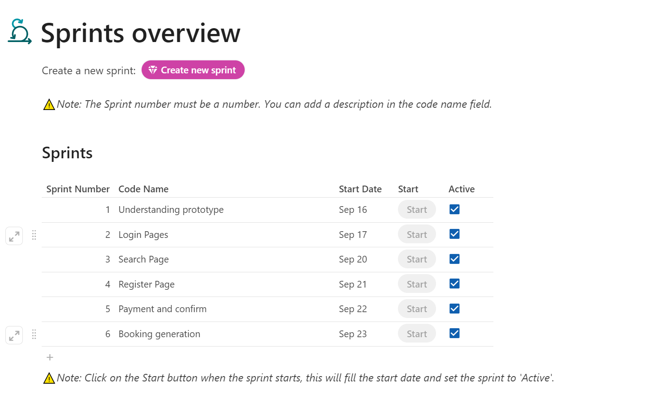

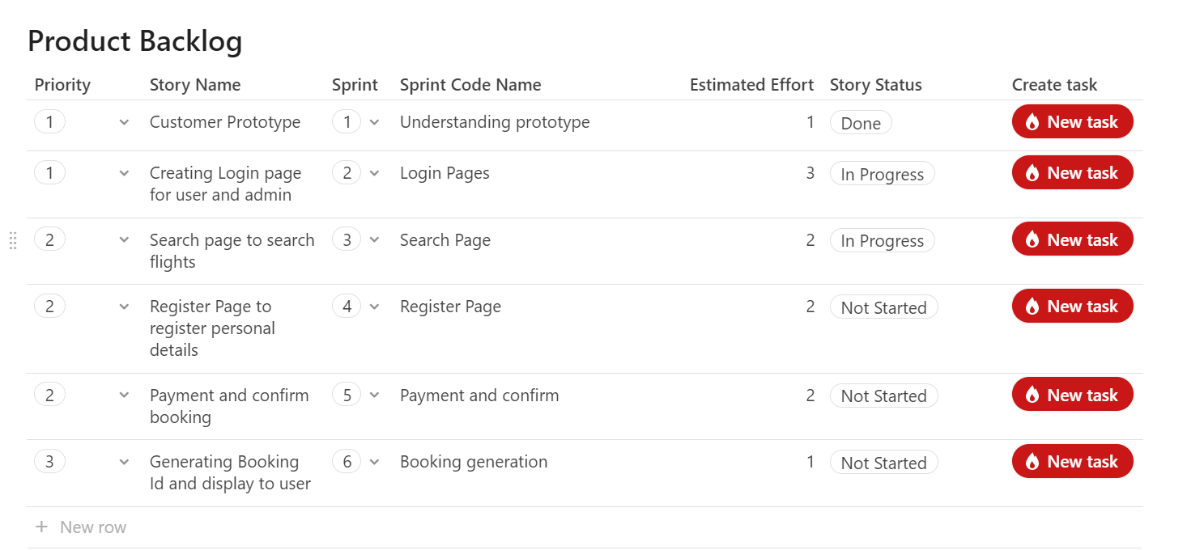

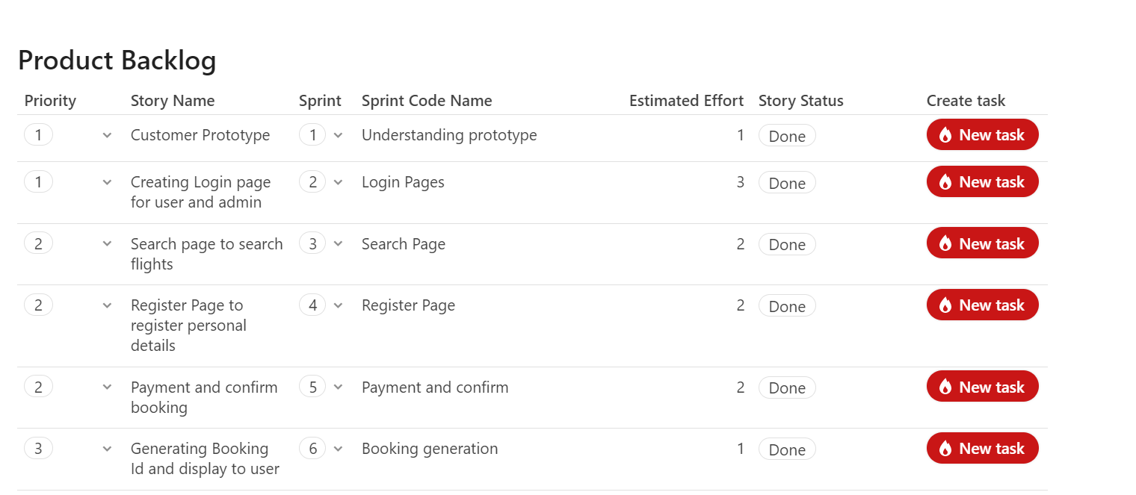

**Technologies Used**

* JSP
* JDBC
* Servlets
* MySQL
* Basic Java Concepts

**Portal Capabilities**

The application has the following capabilities:

1. Admin
   * Change Password
   * See Details of Flights
   * See List of Service Cities
   * List of Airlines Names
2. User
   * Search Flights
   * Book a Flight

**Features of the portal:**

1. **User UI**
2. The portal is designed to book a flight of user’s choice by searching particular flight details according to his/her convenience.
3. The portal is connected to a database to fetch and insert flight/personal/booking and other required details.
4. The following database (MySQL) table with description used in the portal.
   1. Login Table – To store the user and admin credentials.
   2. Flight Details - To store all the detail about a flight (Name, Number, Source City, Destination City, Arrival & Departure Time, Price)
   3. Register Details – To store the personal details of the traveller.
   4. Booking Details – To store the booking details.
5. User should be registered first and have correct login credentials which are there in login table to login into the portal.
6. As soon as the user login, will be directed to search page for searching flight else would be given an error of “Invalid login or New User”.
7. After the search page the user will be displayed a list of all the flight according to the searching parameters entered and need to click on the flight number displayed to book that flight.
8. After flight page user need to enter his personal details which will be then fed into register details.
9. After entering personal details a review page is there to review all the details and confirm the payment Every time the user has to enter a different mail address while registering because it’s primary key hence cannot be duplicated.
10. One dummy page is there to show payment is received and the necessary changes are updated into the database like booked & available seats.
11. Done page is there to give a user an assurance that his booking is successfully done. He will be provided a unique Booking Id that is generated by mixing flight no. and first digits of mobile no. Booking details will get inserted into booking table.
12. User can book only one seat at a time although he/she can check the no. of seats available at the moment by entering the total number of traveller at the search page and then book as many times.
13. **Admin UI**
14. When the admin will login from his/her user id ([admin@yahoo.com](mailto:admin@yahoo.com)) and his correct password he will be automatically be redirected to Admin page.
15. On admin page he can change his password if wish to and the new password will be updated into login table. If the admin enter different new password and confirm password, will be shown error “Password do not match, go back and correct it”.
16. Admin also can have a Master List of Airlines, a list of flight where each flight has source, destination, name, city and price, a list of all the source, destination cities.

**Conclusion:**

The portal is seamlessly working without any kind of error. The user can only book one seat at a time. Although he can check before booking how many seats are available and then book as many times.  
Admin will automatically be welcomed once login and will be taken to admin dashboard. Only admin has the access to see the data inside database.